Site 195 District 3 Listing Price $52,000

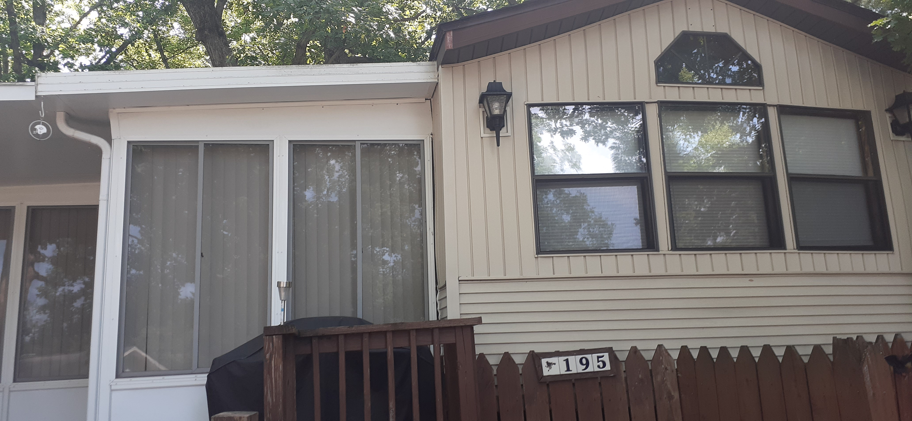 Site Improvements
_X_ Shed
__ Screen house Size: ________
_X_ Decking Size: 436 sq ft
_X_ Add-a-room Size: 12’x20’, 6.75’x6.75’
__ Skirting _X_ Asphalt Drive

Living Accommodations
_X_ Park Model__ Travel Trailer __ RV __ None
Brand: Gulf Stream Year: 1986 Size: 12’x37’
Style: ________________ Number of Bedrooms: 2
Sleeping accommodations: __ king __ queen __double __ twin _X_ bunk __ fold-out _X_ Queen-sized futon
Utilities + Appliances: _X_central A/C _X_ roof A/C _X_stove _X_refrigerator _X_ microwave
Connections: __ telephone _X_ cable TV X electricity X sewer X water

Other Features: New roof October 2022, new toilet July 2022
Across from lower pool, outpost, and playground, winter accessible from the back gate, all furniture included in sale including 2 couches, 3 recliners, kitchen table and chairs, small TV

Exclusions:
There is no bed in the primary bedroom

